Type of the Paper (Write one of the following article types: Original Articles, Reviews, Concepts & Synthesis, Short Communications, Conference Proceedings papers, Comments & Replies)

Title
First name Middle name initials Family (last) name ¹, First name Middle name initials Family (last) name ², First name Middle name initials Family (last) name ^{2,}*
¹ Affiliation 1; e-mail@e-mail.com, If available, the 16-digit ORCID of the author(s)
Received: 1 March 2021
Accepted: 1 May 2021
Published: 1 June 2021

Citation: Lastname, F.; Lastname, F.; Lastname, F. Title. Journal name 2021, NN, N. https://doi.org/NNNNN

² Affiliation 2; e-mail@e-mail.com, If available, the 16-digit ORCID of the author(s)

* Correspondence: e-mail@e-mail.com
Abstract: A single paragraph of about 150-200 words to give a brief introduction to your work. Do not include figure numbers and captions, table numbers and captions, references, or long mathematical expressions.
Keywords: keyword 1; keyword 2; keyword 3 (Enter a maximum of five keywords here)
PACS Number(s): PACS Number 1; PACS Number 2; PACS Number 3 (Enter a maximum of three PACS Numbers here)
or
UDC Number(s): UDC Number 1; UDC Number 2; UDC Number 3 (Enter a maximum of three UDC Numbers here)

1. INTRODUCTION
Main text paragraph. This “Microsoft Word” document is a guide for submitting final paper to the “News of Baku University” journals. Your paper’s format must be strictly followed by this guide and the manuscript cannot be accepted for publication unless all formatting requirements are met.
Contributions to the Journals are to be in Azerbaijan, English and Russian. Authors are encouraged to have their contribution checked for grammar.
In the paper can be only used one style type [Helvetica].
The paper must be on an 8.27-inch x 11.69-inch (21.0 cm x 29.7 cm) page size, and must be in a single, page-wide column. Do not use two or more columns in your paper.
All pages should have a 1-inch (2.54 cm) margin on all sides (top, bottom, right, and left). Final pagination and insertion of running titles will be done by the publisher.
The main title of the paper should be 18pt, full capital letters.
In the “Author Names and Affiliations” prohibited to use any professional title (e.g., Director, Chair of Department et al.), any academic title (e.g., Prof., Dr. et al.) or any membership of any organization. The manuscript has to contain the cover list with:
First line is the Title (centered, 18pt, full capital letters)
The list of authors’ names (centered, 12pt, full letters) follows to title and has to include the names of all authors, the style for the names is initials then surname, with a comma after all but the last two names, which are separated by ‘and’, the initials should not have full stops.
The addresses of the authors’ affiliations (centered, 8pt letters) follow the list of authors. Each address should be contained
in case of higher education organization:
- the department and faculty name;
- the name of the university (or education institute);
- the name of the city and the country;
(e.g., Department of Theoretical Physics, Faculty of Physics, Baku State University, Baku, Azerbaijan).
in case of research institute or center:
- the department or laboratory name;
- the name of the institute or center;
- the name of the city and the country.
(e.g., Division of Biophysics, İnstitute for Physical Problems, Baku State University, Baku, Azerbaijan).

Above displayed numbered lists formatting.
If there is more than one address then a superscripted number, followed by a space, should come at the start of each address. In this case, each author should also have a superscripted number or numbers following their name to indicate which address is the appropriate one for them. Please also provide e-mail addresses for all the authors after the last address like (centered, 8pt letters).
Main text paragraph format with 11pt and 1.15 line spacing.
In the text, reference numbers should be placed in square brackets [X] and placed before the punctuation; for example [2], [3–6] or [6,8]. For embedded citations in the text with pagination, use both parentheses and brackets to indicate the reference number and page numbers; for example [8] (p. 20), or [6] (pp. 1–20). Sample for the main text paragraph: “We begin in section 2 by summarizing our current theoretical knowledge of the …. We then discuss in section 3 …. Finally, in section 4 we discuss …”.
The journal “News of Baku University” accepted the following paper types:
- Original Articles should not exceed 15-20 manuscript pages, and should in no event exceed 30 pages, with appendices, references, tables, and figures.
- Reviews should typically be 50-60 manuscript pages, and should in no event exceed 30 pages, with appendices, references, tables, and figures.
- Concepts & Synthesis should not exceed 30 manuscript pages.
- Short Communications and Conference Proceedings papers should typically be no longer than 2500 words.
- Comments & Replies are usually not exceeding 600 words.
Above displayed bulleted lists formatting.
Save your file in docx format (Word 2007 or higher) or doc format (older Word versions).

2. SECTION (HEADING 1)
Main text paragraph. For the first level section headings should be used bold font, full capital letters and 12pt (e.g., “1. INTRODUCTION”). The main text paragraph should start on a new line.

2.1. Subsection (Headings 2)
Main text paragraph. For the second level section headings should be used italic font 11pt (i.e., “3.1. Subsection”). The main text paragraph should start on a new line.

2.1.1. Subsubsection (Headings 3): Main text paragraph. For the third level section headings should also be used italic font 11pt but should end with a colon (:). The text for that section should run on and not start as a new paragraph.

2.2. Figures and Tables
Main text paragraph. All figures and tables should be cited in the main text as Figure 1, Table 1, etc.
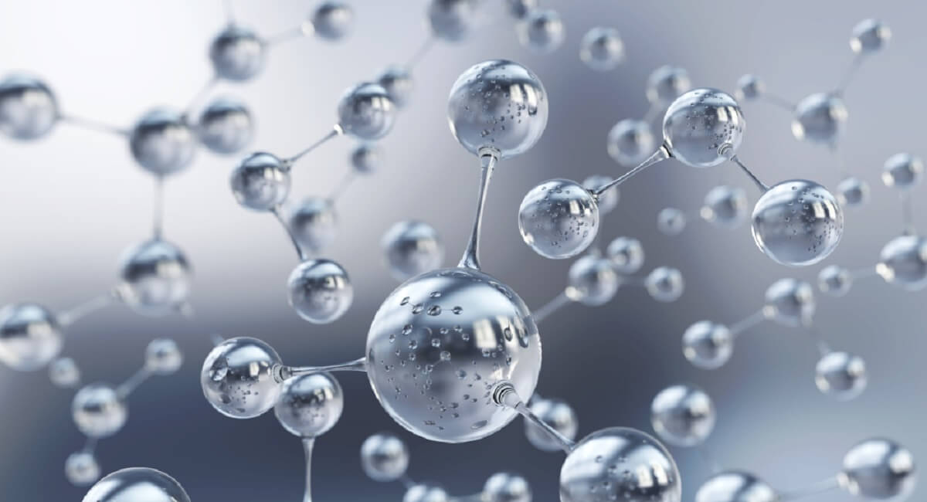
Figure 1. This is a figure. Figure captions must be below the figure, in 10pt font and centered.

Table 1. This is a table (with no column lines!). Tables should be placed in the main text near to the first time they are cited. Table captions must be above the table and in 10pt font and centered.
1 | 2 | 3
A | value | value
B | value | value ¹
¹ Tables may have a footer.
Main text paragraph.

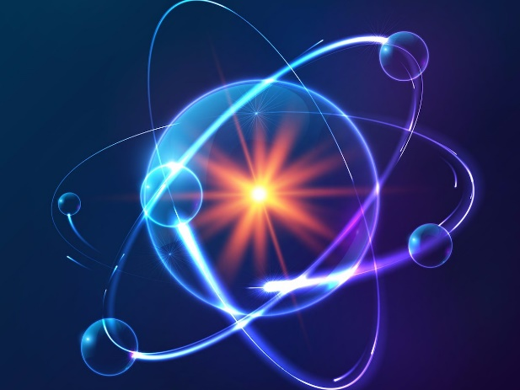 | 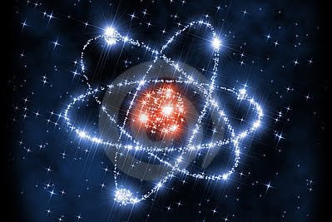
(a) | (b)
Figure 2. These are figures and they should be listed as: (a) Description of what is contained in the left panel; (b) Description of what is contained in the right panel. Figure captions must be below the figure, in 10pt font and centered.

Table 2. This is a table (with no column lines!). Tables should be placed in the main text near to the first time they are cited. Table captions must be above the table and in 10pt font and centered.
1 | 2 | 3 | 4
A | value | value | value
 | value | value | value
 | value | value | value
B | value | value | value
 | value | value | value
C | value | value | value
 | value | value | value
D | value | value | value
 | value | value | value

3.3. Formatting of Mathematical Components
Main text paragraph. Use the equation editor or MathType for equations. 1st example of an equation:
$$f\left(x\right)=a_{0}+\sum_{n=1}^{∞}{\left(a_{n}\cos{\frac{nπx}{L}}+b_{n}\sin{\frac{nπx}{L}}\right)},$$ | (1)
and 2nd example of an equation:
$${\left(x+a\right)}^{n}=\sum_{k=0}^{n}{\left({n \atop k}\right)x^{k}a^{n-k}}.$$ | (2)

4. DISCUSSION AND CONCLUSIONS
Main text paragraph. The majority of this section should be an interpretation of your results.

Funding: This research was funded by [NAME OF FUNDER], grant number [NNN].
Acknowledgments: We are grateful to [First name Middle name initials Family (last) name 1, First name Middle name initials Family (last) name 2, …] for valuable discussions and the referee for useful comments. OR We thank [First name Middle name initials Family (last) name 1, First name Middle name initials Family (last) name 2, …] and the referee for useful comments.
Appendix A
An appendix contains information that is non-essential to an understanding of the paper but may present explanations that further clarifies major aspects of the paper.
Appendix B
An appendix is an optional part of the paper. In the appendices, Figures, Tables, etc. should be labeled starting with “A”—e.g., Figure A1, Table B1, etc.

References

Example References
Journal articles
- Author 1, A.B.; Author 2, C.D. Title of the article. Abbreviated Journal Name Year, Volume, pp. 1–20, DOI
Book and book chapter
- Author 1, A.; Author 2, B. Book Title, 3rd ed.; Publisher: Publisher Location, Country, 2008
- Author 1, A.; Author 2, B. Title of the chapter. In Book Title, 2nd ed.; Editor 1, A., Editor 2, B., Eds.; Publisher: Publisher Location, Country, 2007; Volume 3, pp. 1–20
An unpublished work
- Author 1, A.B.; Author 2, C. Title of Unpublished Work. Abbreviated Journal Name stage of publication (under review; accepted; in press)
Report
- Author 1, A.; Author 2, B. (Institute, City, State, Country). Report title, 2012; pp. 1–20
Patent
- Author 1, A. The title of the patent (if available). Patent Office Name, Patent Number No 123456, May 2020
Conference Paper
- Author 1, A.B.; Author 2, C.D.; Author 3, E.F. Title of Presentation. In Title of the Collected Work (if available), Proceedings of the Name of the Conference, Location of Conference, Country, Date of Conference; Editor 1, Editor 2, Eds. (if available); Publisher: City, Country, Year (if available); Abstract Number (optional), Pagination (optional)
Thesis
- Author 1, A.B. Title of Thesis. Level of Thesis, Degree-Granting University, Location of University, Date of Completion
Websites
- Title of Site. Available online: URL (accessed on Day Month Year)
Newspapers
- Author 1, A.B. (Year, Month Date of Publication). Article Title. Newspaper Title, pp. 3-4 or p. 3. Newspaper homepage URL
Archive materials
- Author (if applicable) / Title of the item (Rule) / date of the item (Rule) / item number (if applicable) / series title (if applicable) / series number (if applicable) / name of the collection (if applicable) / collection number (if applicable) / name of the depository or archive / location of depository (if applicable) / URL or DOI (if applicable)
Letter
- Correspondence from Author’s First name Last name, Data, Letter №, Box №, Archive name, City, Country.
Photographs & Graphic material
- Photograph of Author’s First name Last name, Data, Photographic Collection № or Archive №, City, Country.

Məqalənin növü (Məqalə növlərindən biri yazılır: Orijinal məqalələr, İcmallar, Konsepsiya və Sintez, Qısa mesajlar, Konfrans materialları, Şərhlər və cavablar)

Məqalənin adı
Ad Ata adının inisialları Soyad ¹, Ad Ata adının inisialları Soyad ², Ad Ata adının inisialları Soyad ^{2,}*
¹ İş yeri 1; e-mail@e-mail.com, Mövcuddursa müəlliflərin 16-rəqəmli ORCID məlumatı
Daxil olub: 1 Mart 2021
Qəbul edilib: 1 May 2021
Çap olunub: 1 İyun 2021

İstinad: Soyad Ad.; Soyad Ad; Soyad Ad Məqalınin adı. Jurnalın adı 2021, NN, N. https://doi.org/NNNNN

² İş yeri 2; e-mail@e-mail.com, Mövcuddursa müəlliflərin 16-rəqəmli ORCID məlumatı

* Yazışma e-mail-i: e-mail@e-mail.com

Xülasə: Bir abzasda 150-200 sözdən ibarət olmaqla işin xülasəsi verilir. Şəkil nömrələri və yazıları, cədvəl nömrələri və yazıları, istinadlar və ya uzun riyazi ifadələr istifadə edilməməlidir.
Açar sözlər: açar söz 1; açar söz 2; açar söz 3 (Bura ən çox 5 açar söz daxil edilə bilər)
PACS Nömrə(lər): PACS Nömrə 1; PACS Nömrə 2; PACS Nömrə 3 (Bura ən çox 3 PACS Nömrə daxil edilə bilər)
və ya
UOT Nömrə(lər): UOT Nömrə 1; UOT Nömrə 2; UOT Nömrə 3 (Bura ən çox 3 UOT Nömrə daxil edilə bilər)

